This document is summary of the tasks performed for assignment 1 which covers the topics covered in the first three weeks of Data Bootcamp at Just IT: Data and data structures, Development of datasets using Excel, and Introduction to Tableau. It is based on a measure of the Wealth of Nations using three variables: Gross Domestic Product for 228 Countries (2003 to 2020), Life Expectancy for 196 Countries in 2020 and Ownership of Smart Phones for 74 Countries in 2020. The ultimate aim of the project is to create a dashboard using Tableau.

HT

**Assignment 1: Data Visualization**

**Peter Acol**

**Date of Submssion: 29th June 2024**

**Contents**

**Assignment Requirements** 2

• Cover page 2

• Table of Contents 2

• Main body 2

• A reflective 2

**Assignment 1 Data Story Telling** 2

**Scenario** 2

**First Task** 2

**Policies and Procedures** 2

**Second task** 4

**Excel** 4

**The data** 5

**Third Task** 21

**Tableau** 21

**Reflective Account** 22

# **Assignment Requirements**

This is my first portfolio assignment for Data Visualization using Excel and Tableau, and will be covering our technical training for week 1 to week 3 as outlined below:

1. Data and Data Structures
2. Development of Data sets using Excel
3. Introduction to Tableau

I have been given a scenario and a list of tasks that I will need to cover in order to complete my first consolidation project. There are certain requirements that I should follow when producing my project and they are as follows:

* Cover page including the title of my project, my name, and the date of submission.
* Table of Contents to direct the reader to each individual section of the report.
* Main body of the report and this includes screen shots of my process throughout the project with a detailed definition of the image. This is to help the Trainer evaluate my learning understanding.
* A reflective account to evaluate my project, including what went well and areas for development and lessons learned.

# **Assignment 1 Data Story Telling**

## **Scenario**

Data visualisation has become an essential business capability that helps transform information into insights that can drive meaningful business outcomes and improved experiences. Today, most organizations have accumulated a wealth of data from the different corners of their businesses. However, some of them are unable to see how this data can help them take actions, make better decisions and achieve the desired results.

I have been asked to look at the data workbook and familiarize myself with this data. I have also been asked to create a visual report that will show the data in the form of charts and maps using Tableau to the client’s requirements. I will also need to consider data protection and computer misuse policies.

# **First Task**

## **Policies and Procedures**

The first part of my assignments will be to outline what policies need to be adhered to when working with data.

I am going to be working with ‘The Wealth of nations’ data. I will investigate by researching the internet or looking back at my notes to tell what and why these policies need to be adhered to while using this data. Also tell why it is important to be aware of these rules as a data analyst .

**Policies and Procedures when using Dat**

**Why is this important?**

According to the Information Commissioner’s Office, policies and procedures provide clarity and consistency, by communicating what people need to do and why. Policies can also communicate goals, values and a positive tone.

Data protection law specifically requires organisations to put in place data protection policies where proportionate. What you have policies for and their level of detail varies, but effective data protection policies and procedures can help organisations to take the practical steps to comply with their legal obligations.

**The Data Protection Act**

The Data Protection Act 2018 controls how your personal information is used by organisations, businesses or the government.

The Data Protection Act 2018 is the UK’s implementation of the General Data Protection Regulation (GDPR). Following the introduction of the GDPR in 2018, many companies are faced with challenges regarding how to deal with the requirements.

These challenges are still true upto the present moment. The proper processing and handling of personal data is not only an ethical responsibility, but also a legal requirement which, if not complied with, may lead to huge GDPR fines, financial consequences, and loss of reputation.

Everyone responsible for using personal data has to follow strict rules called ‘data protection principles’.

They must make sure the information is:

* used fairly, lawfully and transparently
* used for specified, explicit purposes
* used in a way that is adequate, relevant and limited to only what is necessary
* accurate and, where necessary, kept up to date
* kept for no longer than is necessary
* handled in a way that ensures appropriate security, including protection against unlawful or unauthorised processing, access, loss, destruction or damage.

The GDPR sets out seven principles for the lawful processing of personal data. Processing includes the collection, organisation, structuring, storage, alteration, consultation, use, communication, combination, restriction, erasure or destruction of personal data.

Broadly, the seven principles are :

1. Lawfulness - Having a legal basis, being transparent and acting in the best interests of the person
2. Purpose limitations - Only process personal data for the purpose it was intended for
3. Data minimization - Only gather and keep the exact amount of data that is needed
4. Accuracy - Take ‘reasonable measures’ to have the most accurate possible data
5. Storage limitation - Don’t store personal data you do not need anymore
6. Integrity and confidentiality (security) – Only people who are processing the data should have access to it
7. Accountability – The data controller or data processor is responsible for complying with the GDPR

The principles are at the centre of the GDPR because they are the guiding principles of the regulation and compliant processing.

Data controllers are responsible for complying with the principles and letter of the regulation. Data controllers are also accountable for their processing and must demonstrate their compliance

A data controller determines the purposes and means of processing personal data. In other words, the data controller decides the how and why of a data processing operation.

A data controller can be a legal person, for example a business (organisation), a public authority, an agency or other body.

Examples of data controllers:

* government agencies that process personal data of citizens
* associations that process the data of their members.
* schools or universities that process personal data of students and teachers.
* hospitals that process personal data of their patients.

**Computer Misuse Act (1990)**

The Computer Misuse Act protects personal data held by organisations from unauthorised access and modification).

The act makes the following illegal:

1. Unauthorised access to computer material. This refers to entering a computer system without permission (hacking).
2. Unauthorised access to computer materials with intent to commit a further crime. This refers to entering a computer system to steal data or destroy a device or network (such as planting a virus).
3. Unauthorised modification of data. This refers to modifying or deleting data, and also covers the introduction of malware or spyware onto a computer (electronic vandalism and theft of information).
4. Making, supplying or obtaining anything which can be used in computer misuse offences.

**Data Analyst’s responsibility**

As a data analyst, it is important to understand the importance of data protection and the steps that must be taken to ensure that sensitive information is kept secure.

Data protection refers to the measures put in place to prevent unauthorized access, use, alteration, disclosure, or destruction of personal information. This includes both paper and electronic records.

Data security is vital for preventing data breaches and cyber-attacks, whereas data privacy is essential for maintaining confidentiality and protecting individuals' privacy rights

The first step in protecting data is to identify what information needs to be protected and who should have access to it. This helps to determine the level of security required for different types of data. Next, strong passwords should be used for all systems and accounts, and all software and systems should be updated regularly to ensure that security vulnerabilities are addressed.

Encryption is also an important aspect of data protection. This involves converting sensitive data into a code that can only be deciphered by authorized parties. This helps to prevent unauthorized access, even if the data is intercepted in transit.

Regular backups of all data are also critical, as this helps to ensure that if data is lost or damaged, it can be recovered. Additionally, it is important to regularly monitor systems and logs to detect any unauthorized access or breaches.

Finally, all employees should be trained in data protection practices, including the importance of keeping passwords secure, how to encrypt sensitive data, and the consequences of not following data protection policies.

In conclusion, data protection is a critical aspect of the role of a data analyst and must be taken seriously to ensure that sensitive information is kept secure. By implementing strong security measures, regularly monitoring systems, and training employees, a data analyst can help to ensure that data protection is maintained at all times.

# **Second task**

## **Excel**

For the second task in this assignment, I will be working with ‘The Wealth of nations’ file **(The Wealth of nations.xlsx**) which I have downloaded from Teams on my PC.

## **The data**

The Excel file has three tabs (sheets), which have been named accordingly and consist of the following datasets:

1. Sheet 1 (GDP) - Ranking of Gross Domestic Product (GDP) per capita figures for 228 countries for selected years between 2003 and 2020.
2. Sheet 2 (Life Expectancy) - Ranking of Life Expectancy figures for 196 countries for the year 2020.
3. Sheet 3 (Smartphones) - Ranking of Smartphone users for 74 countries for the year 2020.

For this task, I will only be working with the GDP dataset which is found on the first tab (GDP) in the Excel file.

The Excel task to be performed on the GDP dataset are as follows:

1. Task 1: Set a password to protect the workbook (The Wealth of the nations(Pacol).xlsx)

I will protect the whole workbook by encrypting it with a password and the protect each of the three (3) sheets with a unique password.

* Open the workbook
* Choose: File > Info > Protect Workbook > Encrypt with Password and a dialog box for Encrypt Document will be displayed as shown in the screen below:

* Choose a strong password to protect the Workbook and click OK.
* You will be asked to Confirm the password and once they match, click OK
* A dialog box shown below will appear to remind you that you will need a password to open the workbook.

**Note: Keep the password in a safe place!**

* Click on the Back side view (back arrow) to go back to the File.

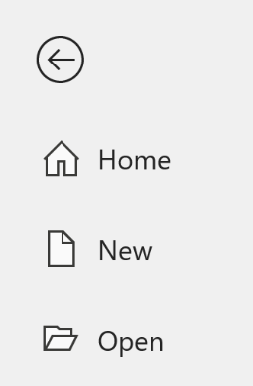

* Save the file and close it.
* Re-open the file to test if the password works.
* You will be prompted to enter the password as shown below:

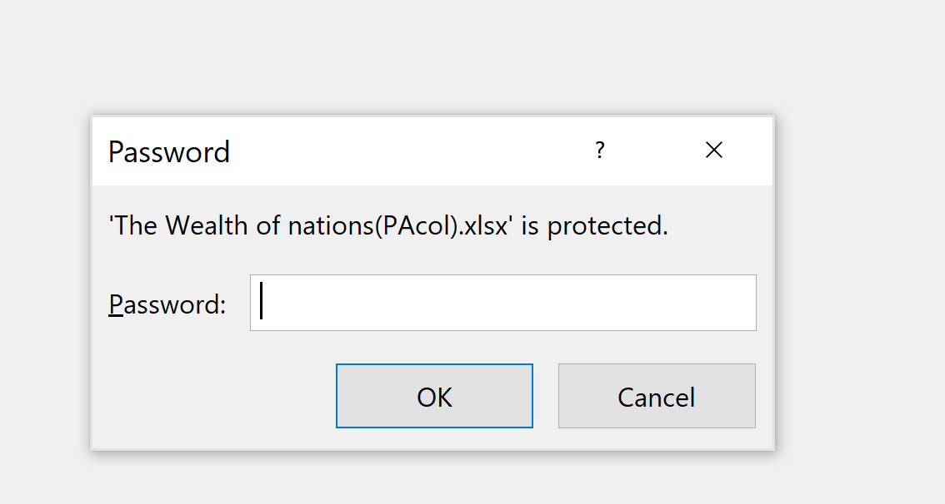

* Enter the password to open the file.
* Once the file is successfully opened, the next step is to protect each of the three (3) sheets with a unique password.
* Right click on GDP sheet name as shown below:

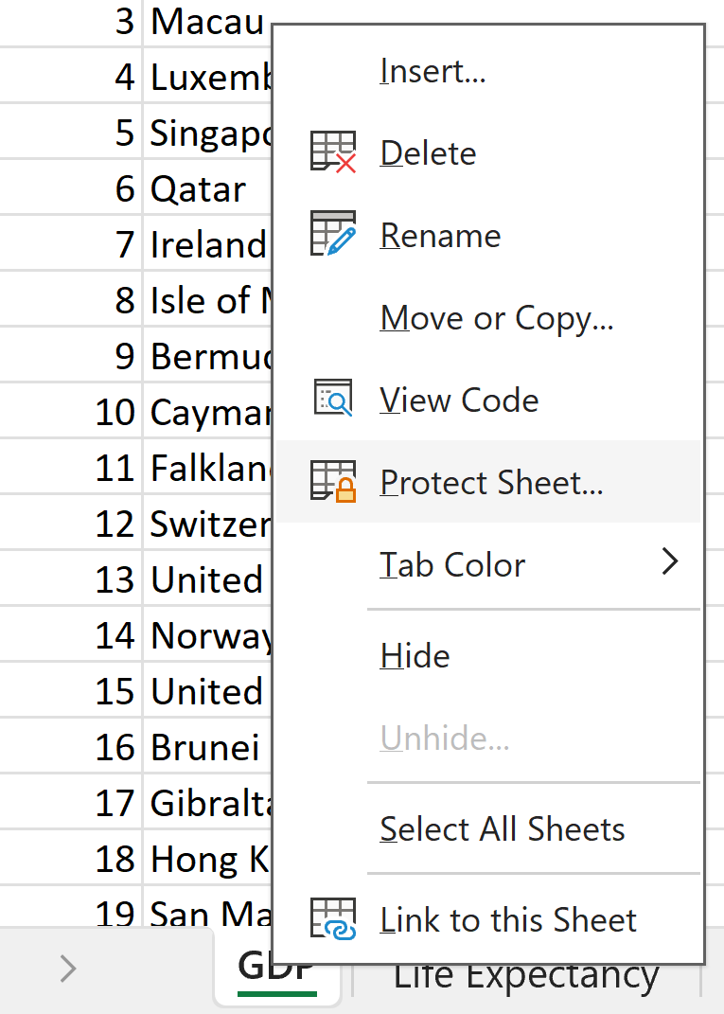

* Choose Protect Sheet option and Protect Sheet dialog box will appear as shown below:
* Choose a strong password and type in the space provided. Leave the default settings and click OK to protect the sheet.
* 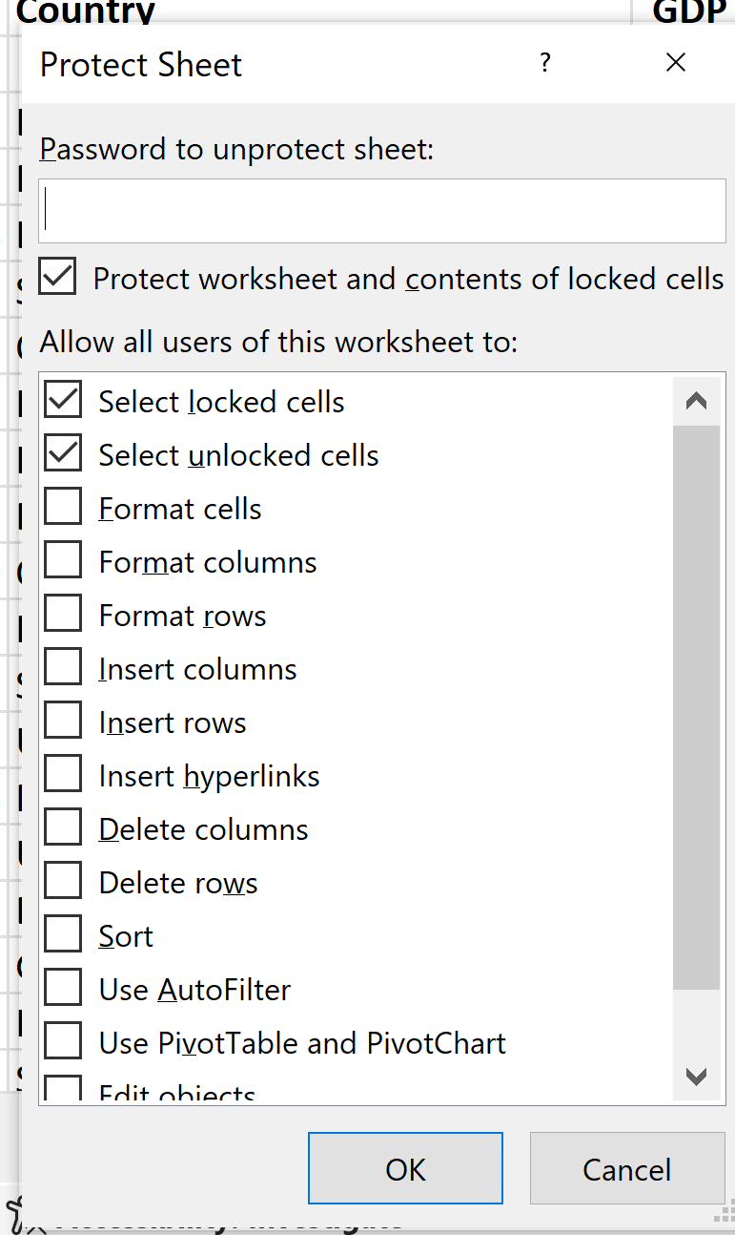
* A dialog box will appear as below to Confirm Password.

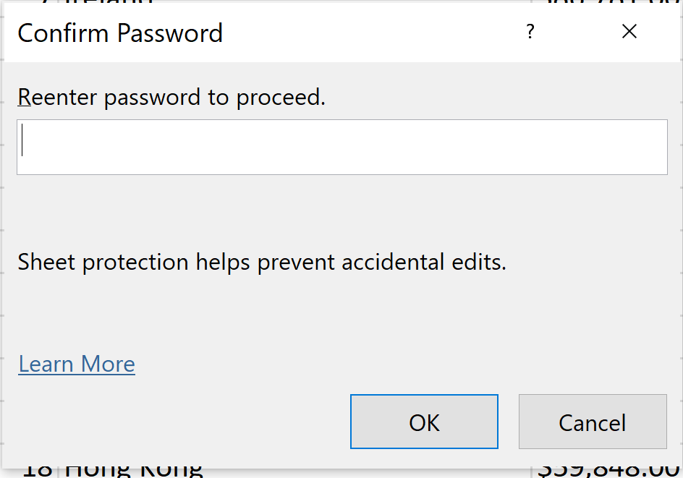

* Type the password and click OK.
* Save the file and close it to test.

**Note: Keep the password in a safe place!**

* Re-open the file and you will be prompted with the password to open file as shown below:

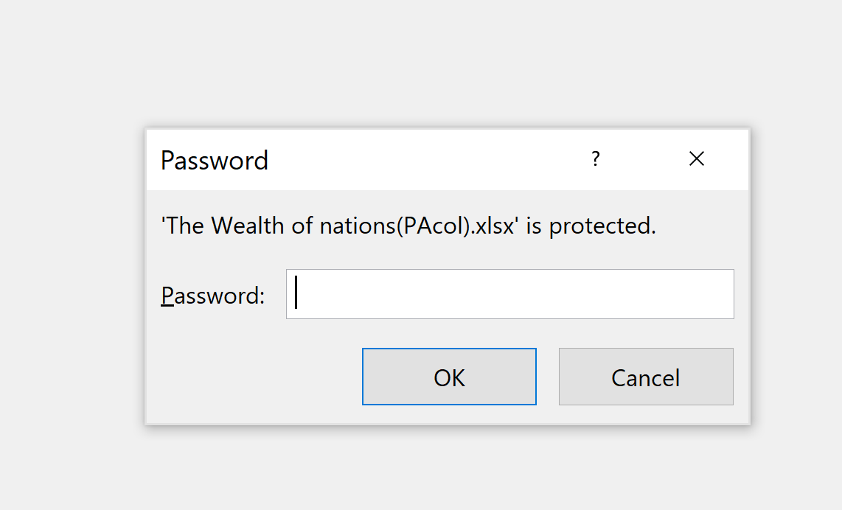

* Type in the password to decrypt the workbook.
* Once the file is opened, when you attempt to make an entry or edit the GDP sheet, you get the message below. This confirms that the sheet is protected!

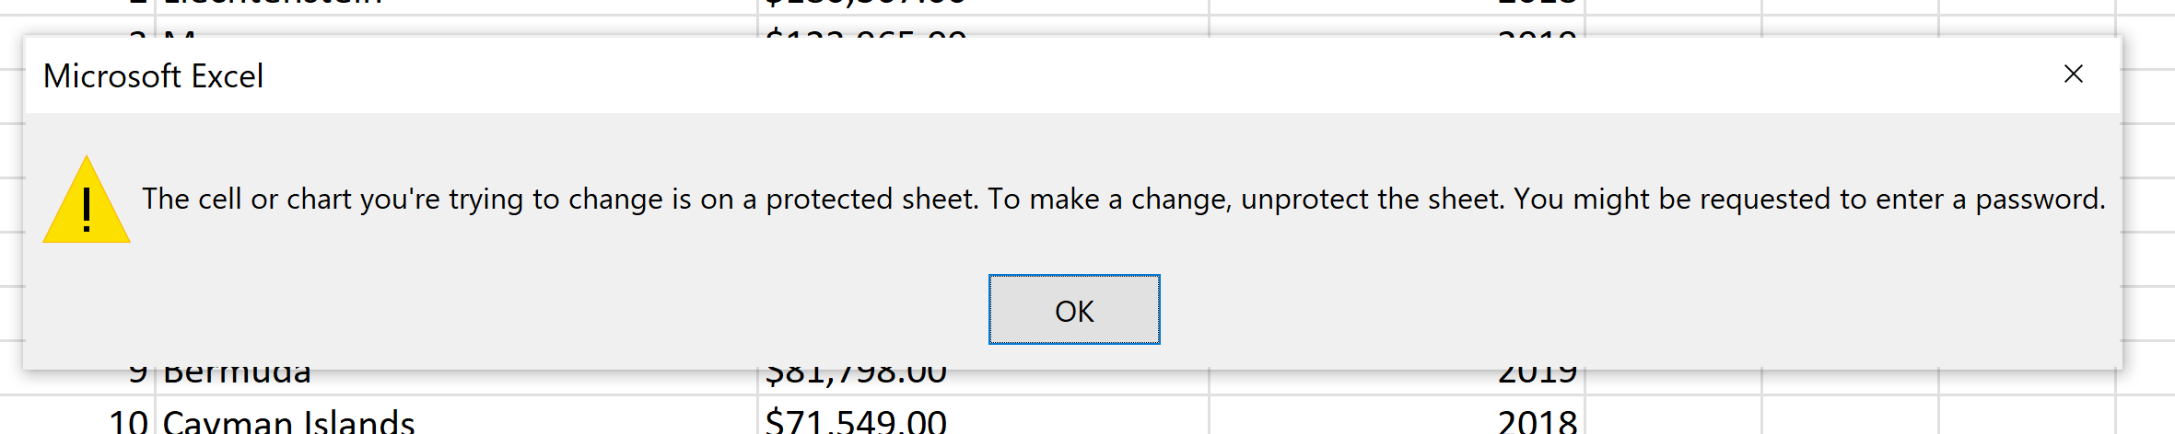

* Protect the Life Expectancy sheet and the Smartphones sheet accordingly using unique password for each,
* Once done, save the workbook.

1. Task 2: Highlight column C and change the data to display in British Pound symbol.

* Open the workbook (if closed)
* Right click the GDP sheet and choose Unprotect Sheet option as shown below:

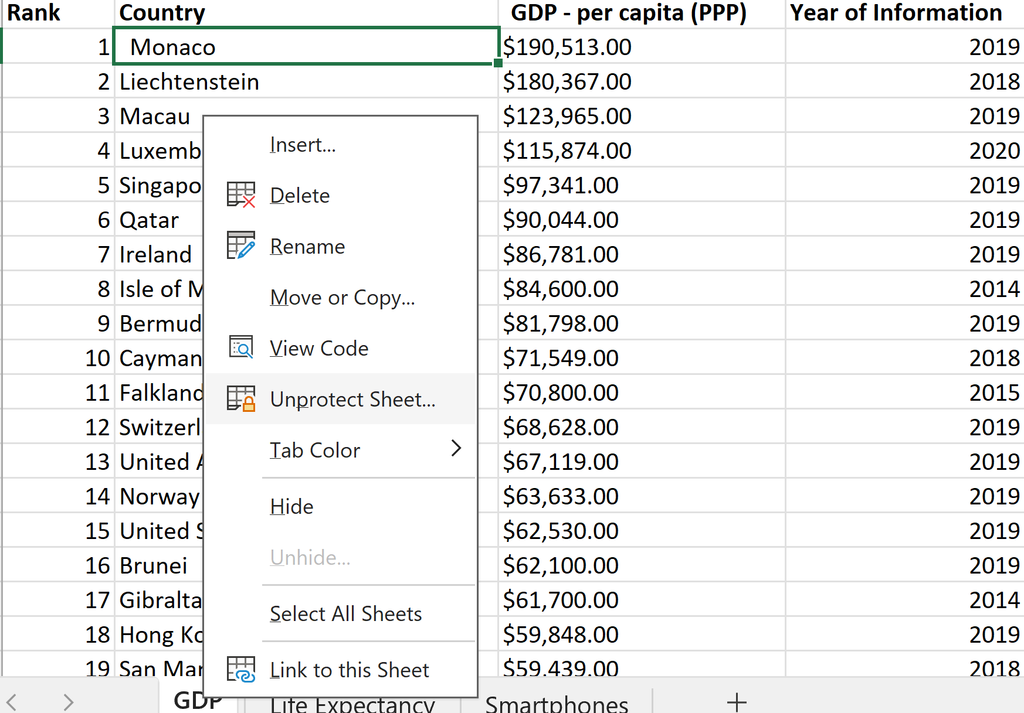

* You will be prompted for a password to Unprotect Sheet as shown below:

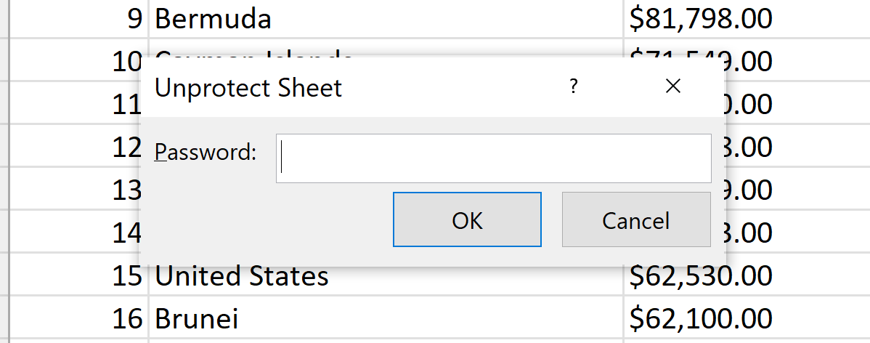

* Enter the correct password for GDP sheet and the sheet is now ready for the task.

Note: The task is for GDP sheet only so the other two sheets should be left protected at this time.

* High column C as shown below:

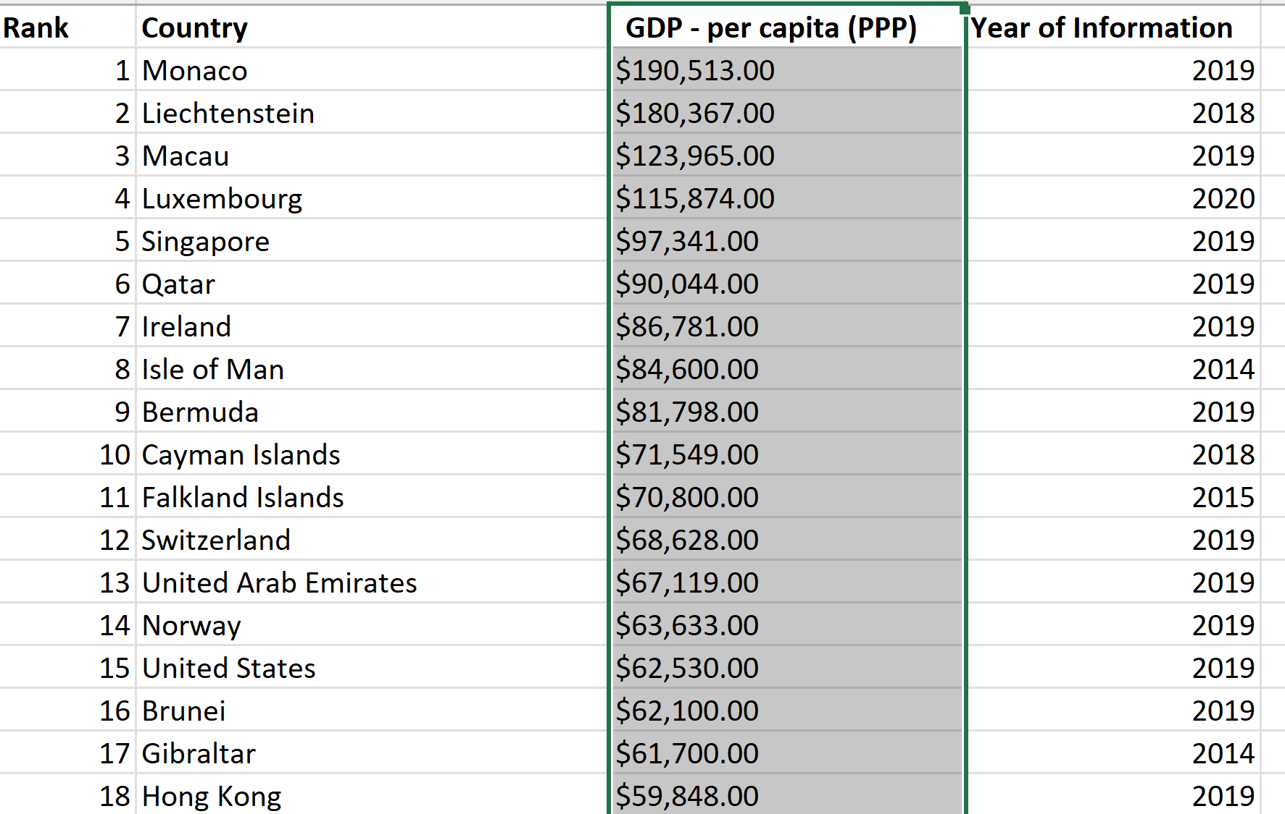

* With the column still highlighted, right click and choose Format Cells from the context menu as shown below:

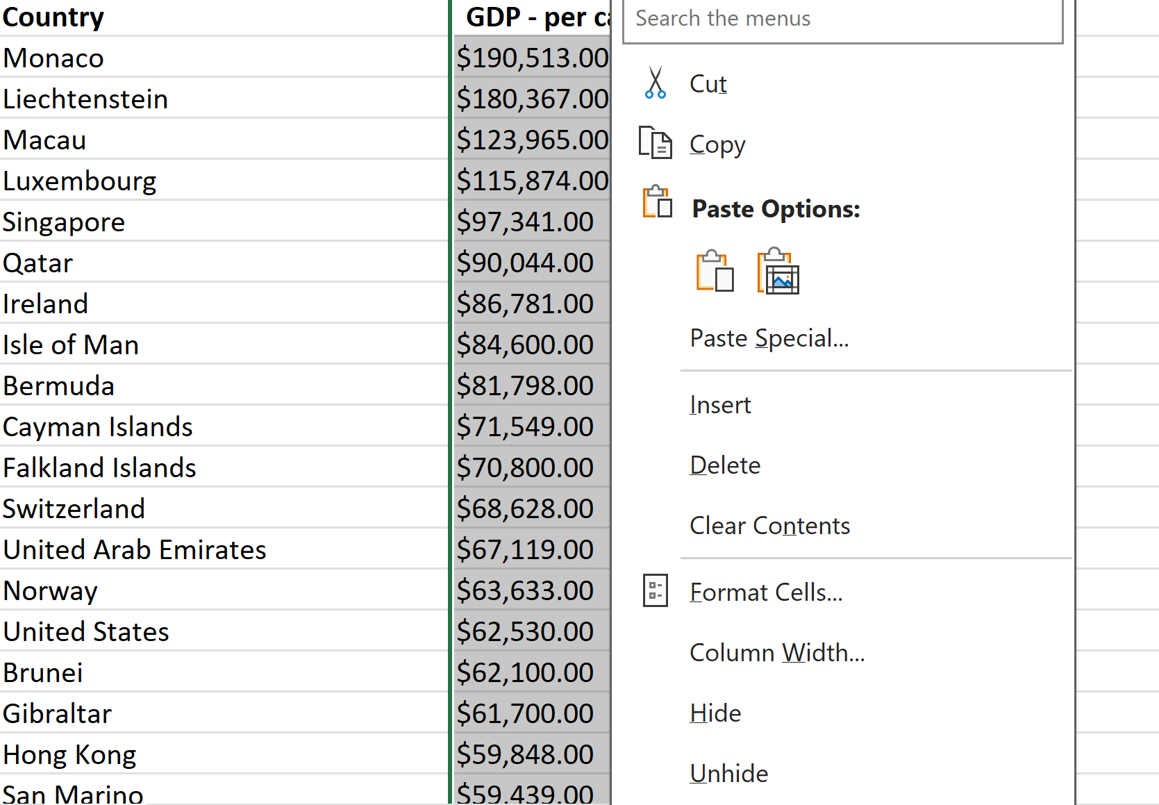

* Choose Custom option as shown below and edit Type to: £#,##0.00 as shown below:

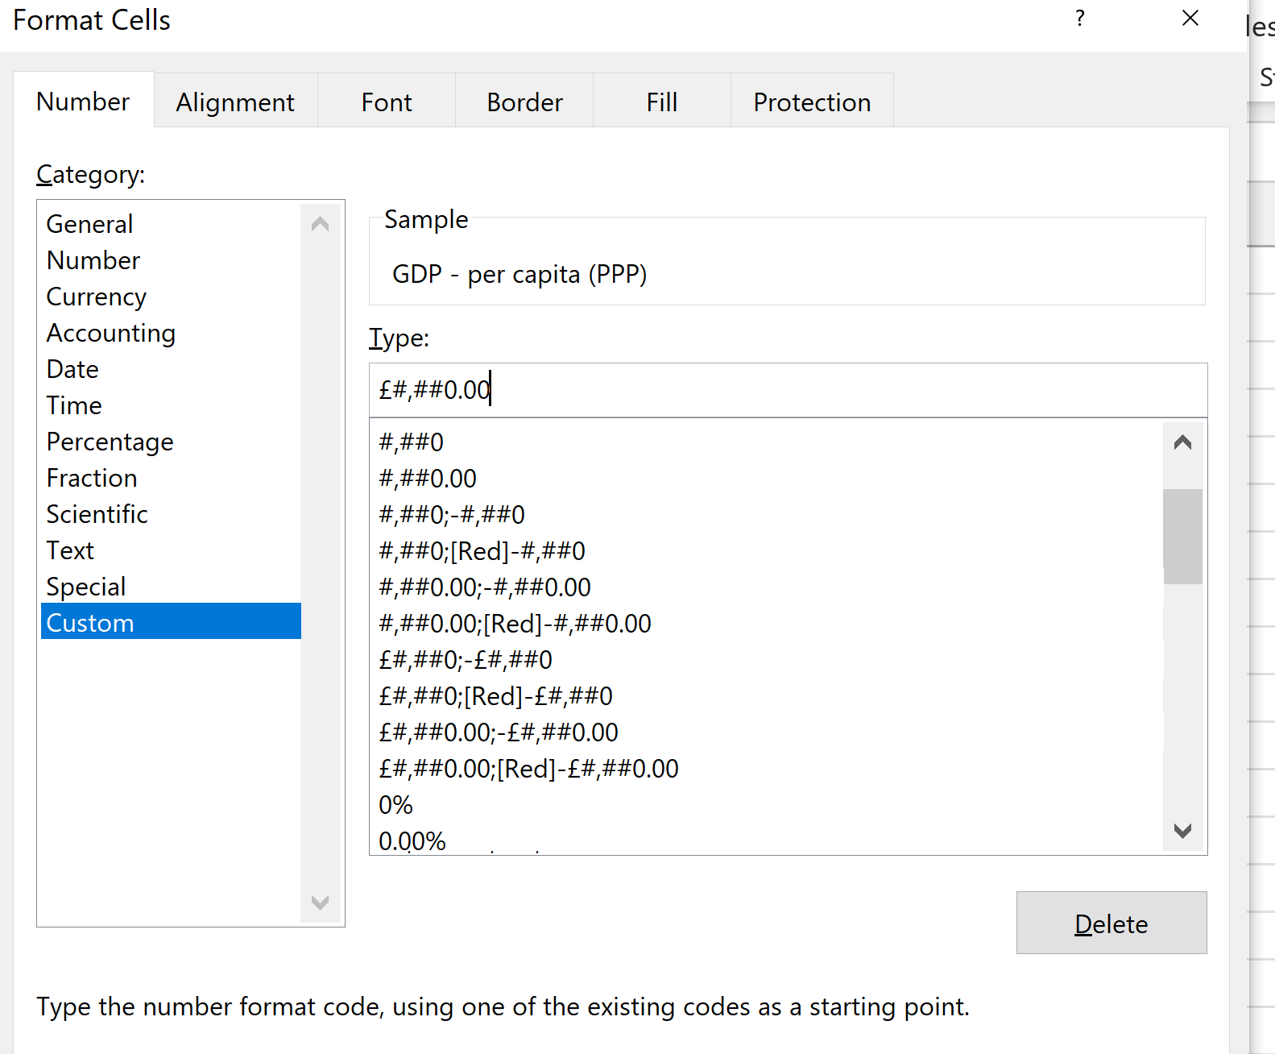

* Click OK to close the dialog box,
* Column C is formatted to British pound symbol as shown below:

|  |  |  |  |
| --- | --- | --- | --- |
| **Rank** | **Country** | **GDP - per capita (PPP)** | **Year of Information** |
| 1 | Monaco | £190,513.00 | 2019 |
| 2 | Liechtenstein | £180,367.00 | 2018 |
| 3 | Macau | £123,965.00 | 2019 |
| 4 | Luxembourg | £115,874.00 | 2020 |
| 5 | Singapore | £97,341.00 | 2019 |
| 6 | Qatar | £90,044.00 | 2019 |
| 7 | Ireland | £86,781.00 | 2019 |
| 8 | Isle of Man | £84,600.00 | 2014 |
| 9 | Bermuda | £81,798.00 | 2019 |
| 10 | Cayman Islands | £71,549.00 | 2018 |
| 11 | Falkland Islands | £70,800.00 | 2015 |
| 12 | Switzerland | £68,628.00 | 2019 |
| 13 | United Arab Emirates | £67,119.00 | 2019 |
| 14 | Norway | £63,633.00 | 2019 |
| 15 | United States | £62,530.00 | 2019 |
| 16 | Brunei | £62,100.00 | 2019 |
| 17 | Gibraltar | £61,700.00 | 2014 |
| 18 | Hong Kong | £59,848.00 | 2019 |

* Save the file

1. Task 3: Turn the GDP sheet into a table.

* Highlight the GDP sheet by selecting Shift+Ctrl+End
* Choose Insert > Table as shown below:

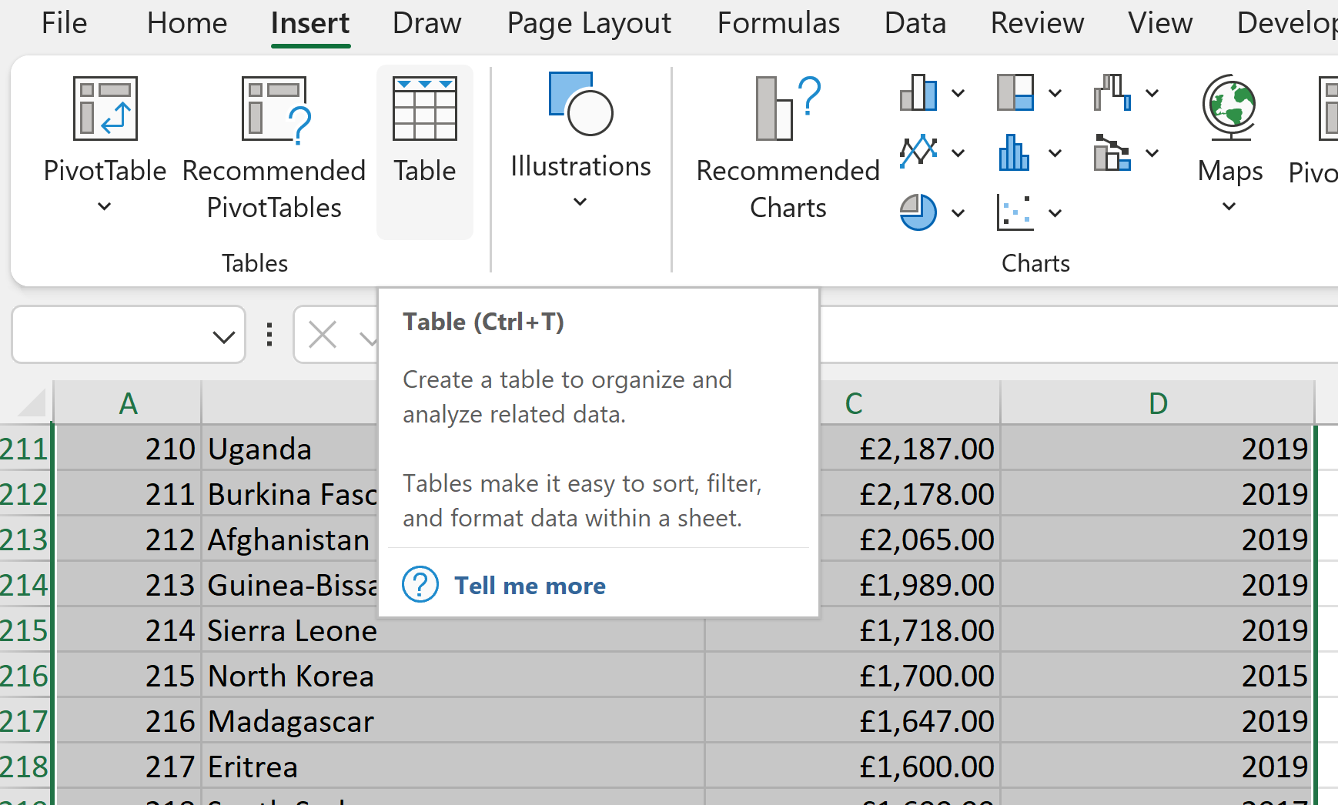

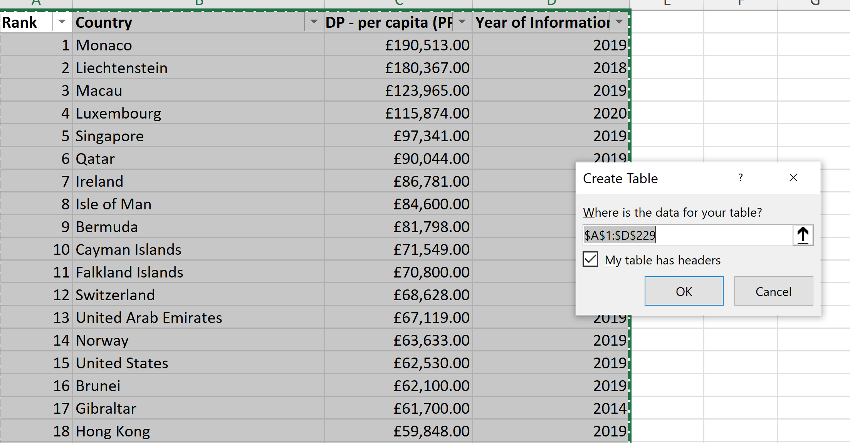

* Click OK to Create Table and the GDP sheet is now turned into a table as shown below:

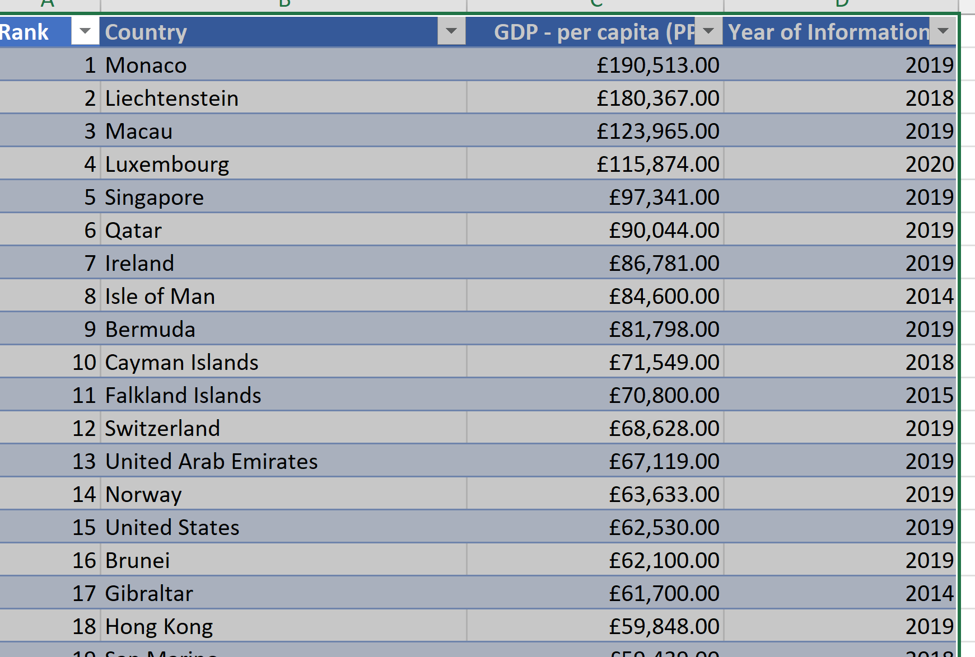

* Save the File

1. Task 4: Filter the table to display only the information for 2019.

* Click on the Filter Option for Column D (Year of Information).
* Deselect All and Choose 2019 only as shown below:

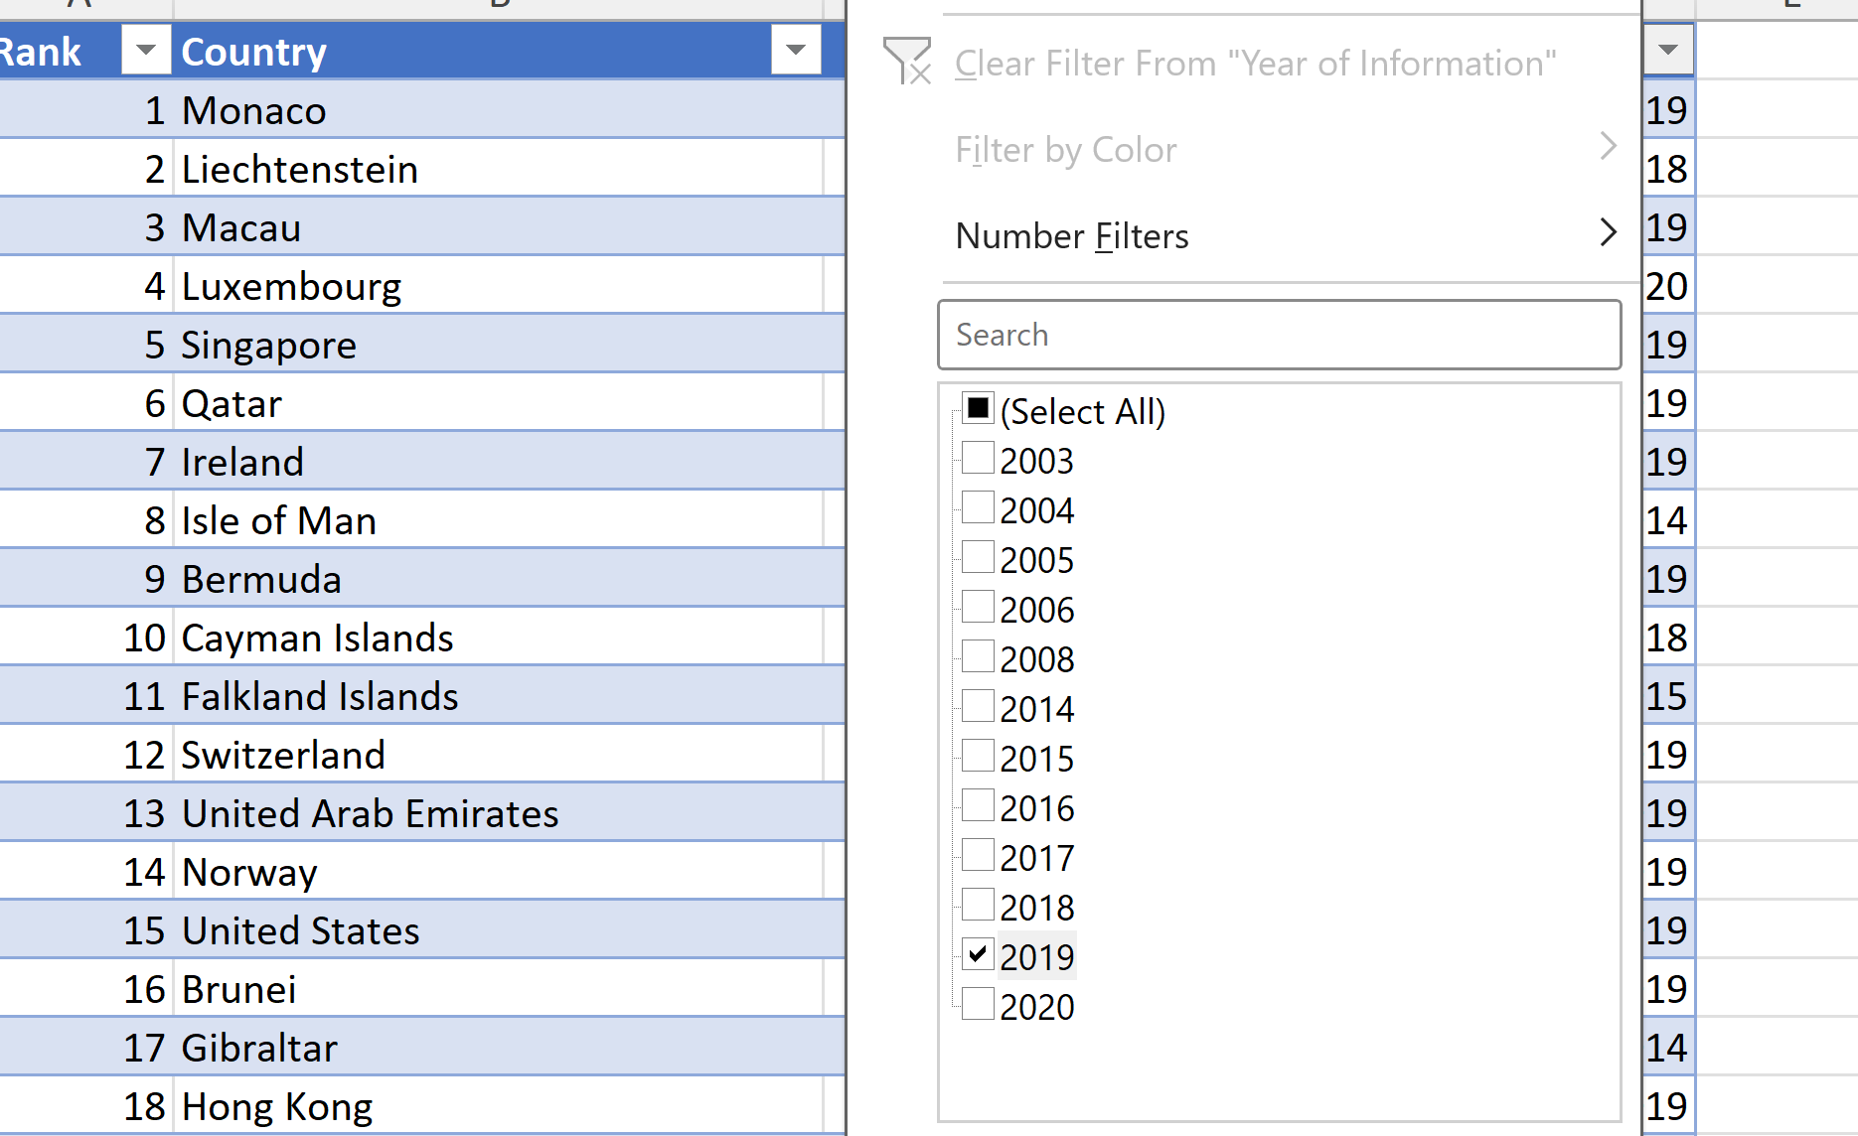

* Click OK.
* The record for 2019 (188 countries) are now displayed as shown below:

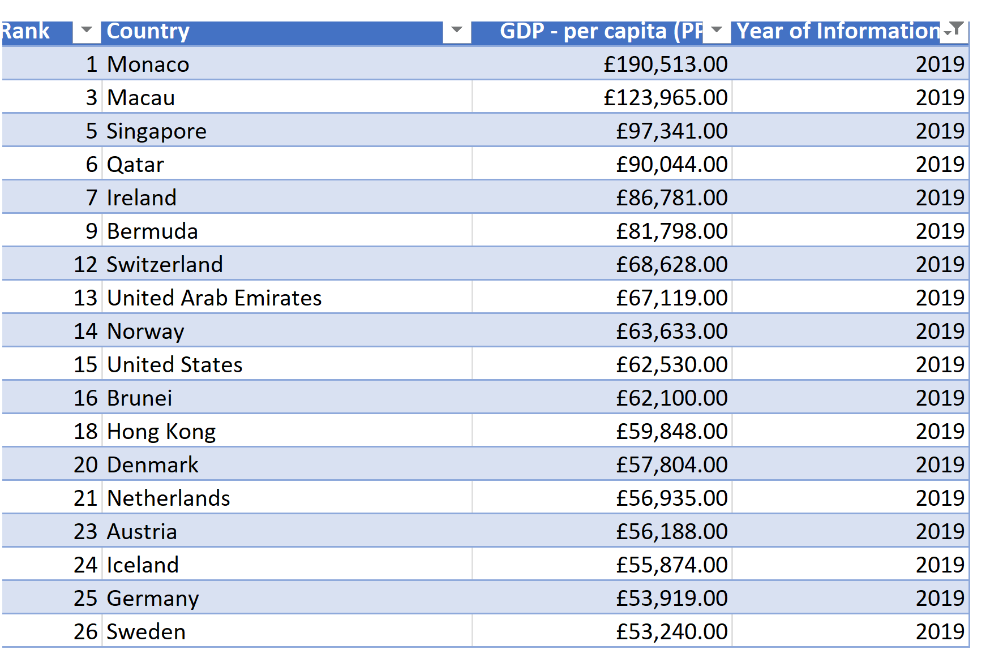

* Save the file

1. Task 5: Next create a chart that will only display the following data ‘Rank, Country and GDP – per capita (PPP). The chart can be anything as long as it is suitable.

* Highlight Columns 1 (Rank), 2 (Country) and 3 (GDP - per capita)
* Select Insert > Chart
* Choose 2-D Clustered Bar Chart and Chart will be displayed on the GDP sheet as shown below:

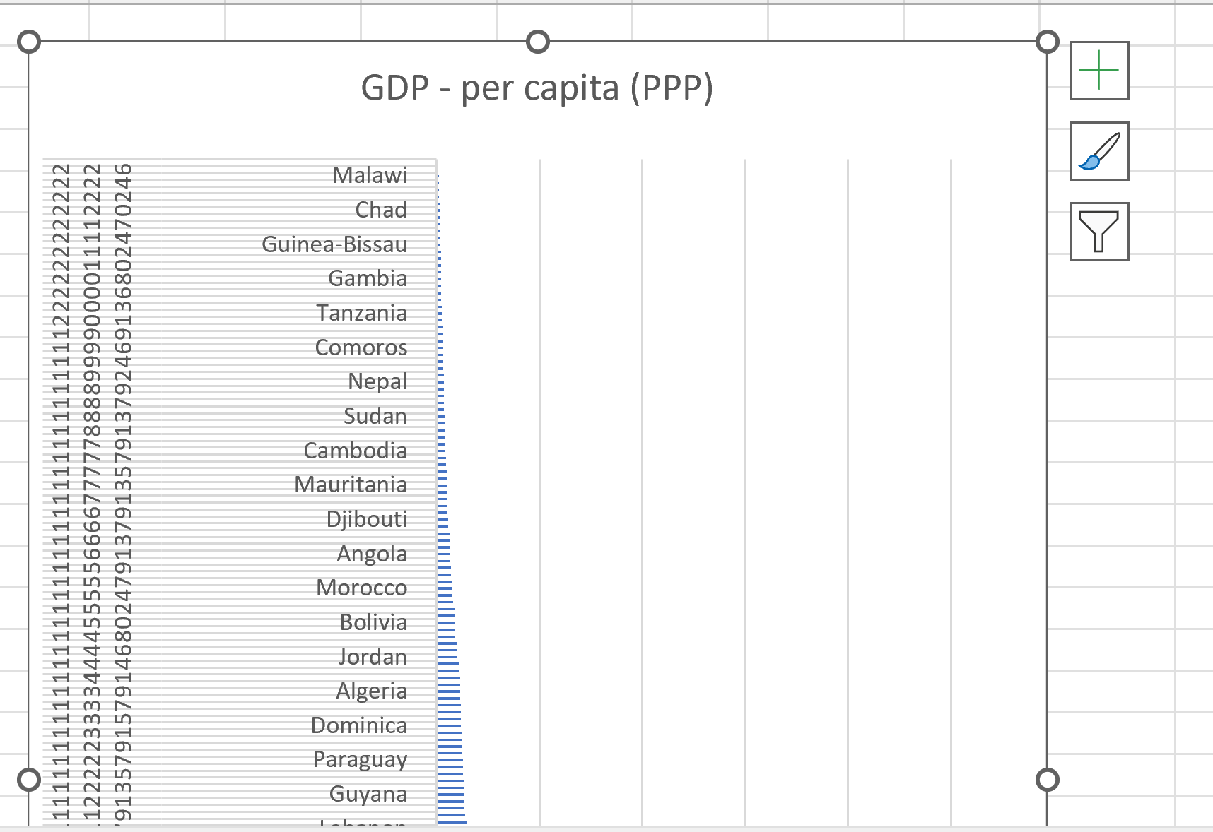

1. Task 6: Using your creative skills edit the chart.
2. Add a title
3. Add X and Y axis labels
4. Make the chart visually pleasing
5. Task 7: Move the chart to a new sheet tab and label with a suitable name.

Sheet named: **Chart_GDP_2019**

1. Task 8: Create a sort for the top 20 highest ranking counties.

1. Task 9: Next create a new Bar chart to display the 20 highest ranking countries from your sort and

then move the chart to be underneath the table.

1. Task 10: Colour the background by highlighting the area underneath the table. Find the add a fill colour icon and select a colour.

1. Task 11: Create 3 macro buttons.

* Create three (3) buttons for each of the three (3) macros as below using shapes tools in word:

**Print Macro**

* Click Developer Toolbar
* Choose Record Macro
* Give the macro an appropriate name with a description as shown below:

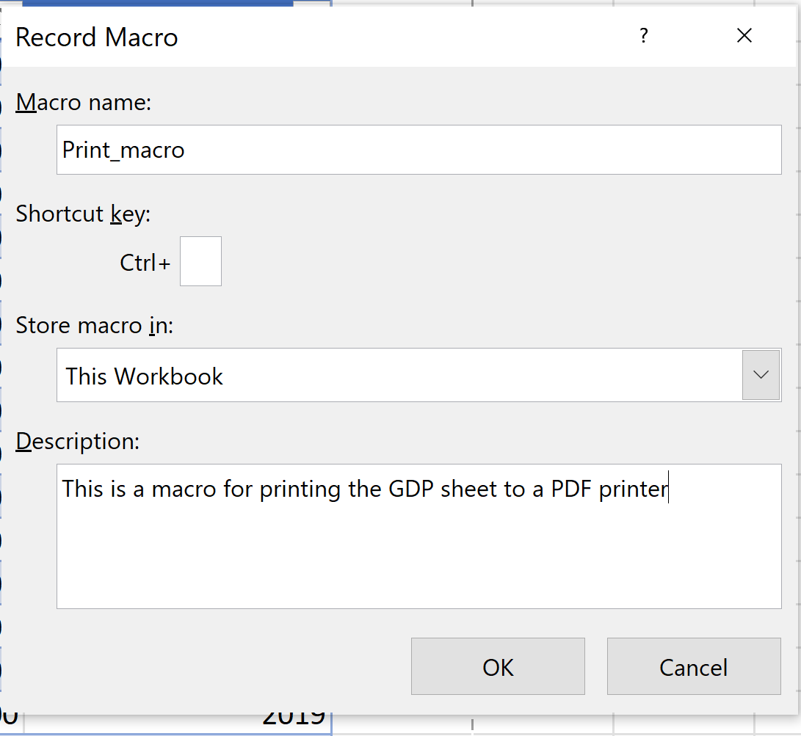

* Click OK to start recording the macro.
* Choose File > Print > and Choose PDF printer as shown below:

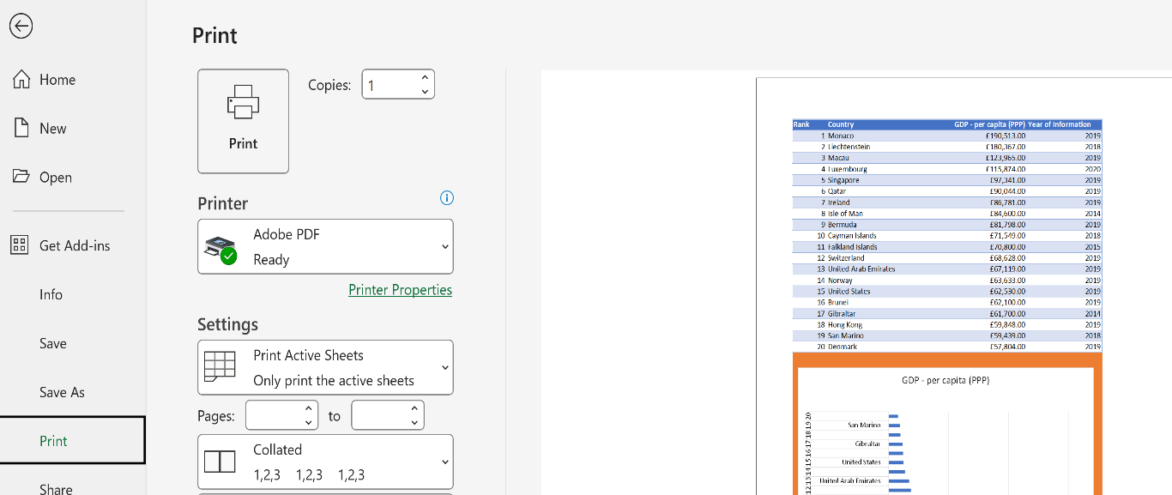

* You will be prompted to Save the PDF file
* Click Save.

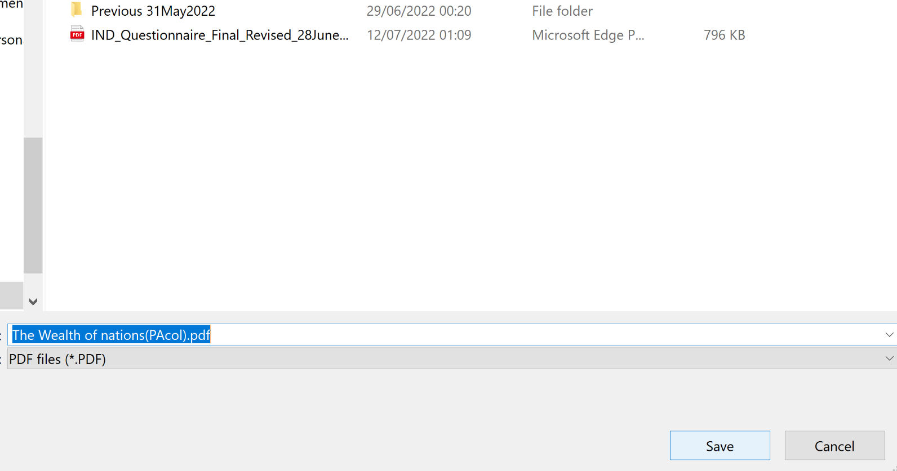

* Stop recording the macro as shown below:

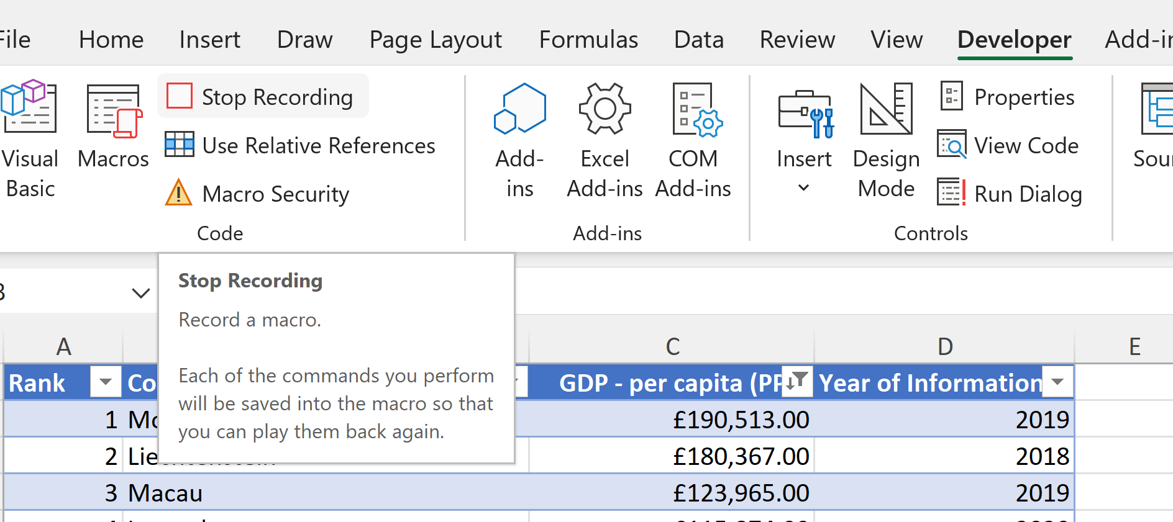

* Right click on the Print Button and assign the Print_macro to the button and a dialog box as shown below:

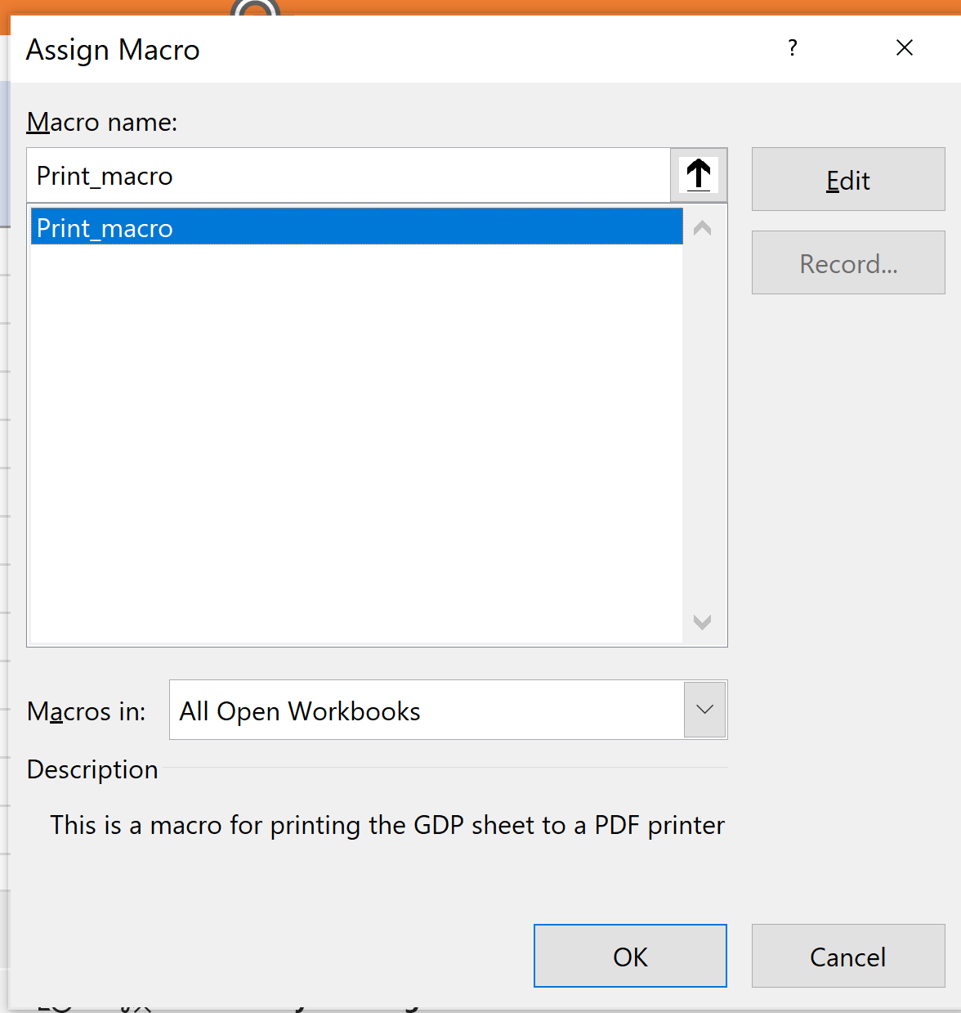

* Click OK to assign the Print_macro to the Button.

Note: The file will now be save as micro-enabled file: The Wealth of nations(PAcol).xlsm

* Click on the Print button below to invoke the Print command to test.

* It works!

**Save Macro**

* Repeat the same process outlined above for recording a Print macro.The only difference is that instead of printing the Worksheet to a PDF printer, it will Save it.

**Copy Macro**

* Repeat the same process outlined above for recording a Copy.The only difference is that instead of saving the Worksheet, we are going to copy an area to be copied as show and follow the same process.
* Assign the **Copy_macro** accordingly.
* Using the copy macro, copy the sheet and then paste it into a new word document keeping the formating. Give the page a title ‘GDP (Gross domestic product)’ .
* Save your document as ‘Word Gross domestic product report 1’**(Done)**
* Before we finish with our excel table ‘Gross domestic product’ sheet, we will add a header and footer to our table.
* In the header enter your name and GLA DATA 1 in the three boxes: **Peter Acol GLA DATA 1**
* In the footer add today’s date **(28th June 2024)** then **Assignment 1** and lastly **Data Visualisation** **(Done!)**
* Save your table as ‘Excel Gross domestic product report 1’ **(Done!)**

# **Third Task**

## **Tableau**

1. **Workflow**

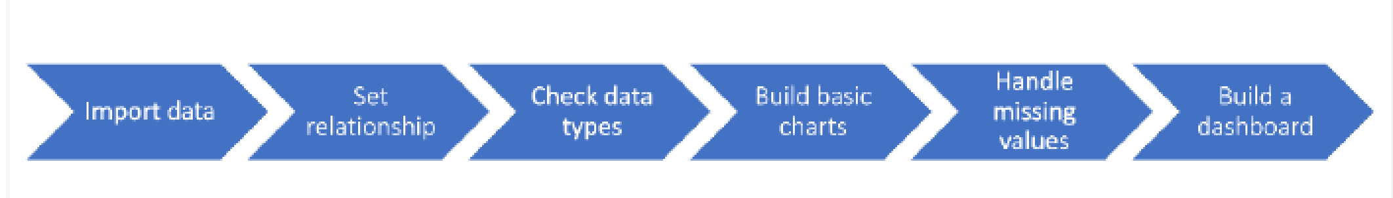

* The following three files were imported into Tableau Desktop:
* GDP
* Life Expectancy
* Smartphones

* The three files had country as the common field.
* The relationships were set accordingly.
* Data types were checked and Year was changed to String instead of Number since we were not going to do any calculations using it.
* Three basic charts and one map were created as follows:
* Clustered Chart: GDP - Top 20 Countries (2003 - 2020)
* Map: GDP - Top 20 Countries (2003- 2020) (Rank)
* Clustered Chart: Life Expectancy - Top 20 Countries in 2020
* Smart Phone Users - Top 20 Countries in 2020
* There were no missing values.
* A dashboard comprising the four visuals above was created (Please link below):

[Data_Visualization_Assignment1 | Tableau Public](https://public.tableau.com/app/profile/peter.acol/viz/Data_Visualization_Assignment1/DashboardWealthofNations?publish=yes)

# **Reflective Account**

The project was a very good way of evaluating my understanding of the topics covered in the first three weeks. I had used Excel before, but I learned some aspects of the application which I had not had the chance to learn before, particularly macros. I am now very comfortable with recording and using macros!

One tool which I had not used before is Tableau, but this project really opened my understanding of the tableau visualization tool. I am now very confident in using Tableau for creatin visuals and dashboards and will include it in my skills toolbox.

All in all, the learning went very well, and I learned a lot of new things and also brushed up on my Excel.

Regarding areas for development, I need to learn more Tableau visualization functionality and tips so as to create more professional dashboards.

**END OF DOCUMENT**